Software: System software
sw_systems.php — Software
Quotes….

Software is much more difficult for people to understand than hardware. Hardware, you can pick it up and touch it and feel it and see what it looks like and so on. Software is more mysterious.
– Bob Taylor Photo by Gardner Campbell [CC BY-SA 2.0 ], via Wikimedia Commons

(talking about Linux) …a world-class operating system could coalesce as if by magic out of part-time hacking by several thousand developers scattered all over the planet, connected only by the tenuous strands of the Internet?
– Excerpt From: Tim O'Reilly. “WTF?.”Photo (CC) Brian Solis, www.briansolis.com / bub.blicio.us
Those parts of the system that you can hit with a hammer are called hardware; those program instructions that you can only curse at are called software.
– Anonymous

Software is a great combination between artistry and engineering.
– Bill Gates

Microsoft loves Linux.
– Satya NadellaPhoto by Brian Smale and Microsoft (Satya Nadella Microsoft leadership profile page) [CC BY-SA 4.0 ], via Wikimedia Commons

I've felt strongly that the advantage of Linux is that it doesn't have a niche or any special market, but that different individuals and companies end up pushing it in the direction they want, and as such you end up with something that is pretty balanced across the board.
– Linus TorvaldsBy Unknown photographer who sold rights to the picture to linuxmag.com [GFDL or CC-BY-SA-3.0], via Wikimedia Commons

Microsoft's Windows 3.1, released in 1992, was the first truly successful edition of Windows and juiced the Redmond juggernaut.
– Walt MossbergBy Andrew Feinberg (DSC_0002.JPG) [CC BY-SA 2.0 or CC BY-SA 3.0 ], via Wikimedia Commons

There's no other company that could make a MacBook Air and the reason is that not only do we control the hardware, but we control the operating system. And it is the intimate interaction between the operating system and the hardware that allows us to do that. There is no intimate interaction between Windows and a Dell notebook.
– Steve JobsPhoto by Matthew Yohe [CC BY-SA 3.0 or GFDL], via Wikimedia Commons
Like car accidents, most hardware problems are due to driver error.
– Author Unkown

If the Net becomes the center of the universe, which is what seems to be happening, then the dizzying array of machines that will be plugged into it will virtually guarantee that the specifics of which chip and which operating system you've got will be irrelevant.
– Marc AndreessenPhoto by Joi [CC BY 2.0 ], via Wikimedia Commons
…like all premium Samsung phones, runs Android with the basic Google suite of apps, Samsung keeps trying to duplicate Android functions with its own software.It wants to be a software platform like its rival Apple, but it uses someone else's operating system and core apps. Awkward.
– Walt MossbergBy Andrew Feinberg (DSC_0002.JPG) [CC BY-SA 2.0 or CC BY-SA 3.0 ], via Wikimedia Commons
Closed environments dominated the computing world of the 1970s and early '80s. An operating system written for a Hewlett-Packard computer ran only on H.P. computers; I.B.M. controlled its software from chips up to the user interfaces.
– Ellen Ullman
The future of Windows is to let the computer see, listen and even learn.
– Bill Gates Photo by DFID - UK Department for International Development (https://www.flickr.com/photos/dfid/14590135480/) [CC BY 2.0], via Wikimedia Commons

In the smart home of the future, there should be a robot designed to talk to you. With enough display technology, connectivity, and voice recognition, this human-interface robot or head-of-household robot will serve as a portal to the digital domain. It becomes your interface to your robot-enabled home.
– Colin AnglePhoto Flikr

All through the 1980s, Apple kept its prices high. There were many reasons Microsoft's much bigger user base managed to resist moving to the GUI - but price was high among them. Steven Levy
– Steven LevyPhoto by Joi [CC BY 2.0 ], via Wikimedia Commons

When designers replaced the command line interface with the graphical user interface, billions of people who are not programmers could make use of computer technology.
– Howard RheingoldBy Joi [CC BY 2.0 ], via Wikimedia Commons
DOS (the CLI) is ugly and interferes with users' experience.
– Bill Gates Photo by DFID - UK Department for International Development (https://www.flickr.com/photos/dfid/14590135480/) [CC BY 2.0], via Wikimedia Commons
I wrote a lot about the need for an information appliance. I think we've pretty much arrived at one: the iPad. A child could figure out how to use it quickly. Compare it to a DOS computer or even an Apple II; it's no longer nearly as much of a hassle or a mystery.
– Walt MossbergBy Andrew Feinberg (DSC_0002.JPG) [CC BY-SA 2.0 or CC BY-SA 3.0 ], via Wikimedia Commons

I feel like touchscreen technology blows my mind still. It just makes me think of all of the sci-fi films I enjoyed as a kid.
– Joe TrohmanBy Arturo Pardavila III from Hoboken, NJ, USA [CC BY 2.0 ], via Wikimedia Commons

The hands are the instruments of man’s intelligence.
– Maria MontessoriSee page for author [Public domain], via Wikimedia Commons
First was the mouse. The second was the click wheel. And now, we're going to bring multi-touch to the market. And each of these revolutionary interfaces has made possible a revolutionary product - the Mac, the iPod and now the iPhone.
– Steve JobsPhoto by Matthew Yohe [CC BY-SA 3.0 or GFDL], via Wikimedia Commons

As far as the customer is concerned, the interface is the product.
– Jef RaskinBy Aza Raskin;Perteghella at it.wikipedia [CC BY 2.0 or CC BY 2.5 ], from Wikimedia Commons

Neural implants could accomplish things no external interface could: Virtual and augmented reality with all five senses; augmentation of human memory, attention, and learning speed; even multi-sense telepathy - sharing what we see, hear, touch, and even perhaps what we think and feel with others.
– Ramez NaamBy Sebastiaan ter Burg from Utrecht, The Netherlands [CC BY 2.0 ], via Wikimedia Commons

In addition to making Android available for free, Google also lets phone makers change the code and customize it so that an Android phone made by, say, Samsung has a different user interface than an Android phone from Motorola.
– Daniel LyonsBy Mark Coggins from San Francisco (Fake Steve Jobs) [CC BY 2.0 ], via Wikimedia Commons

I am extraordinarily fascinated by the future of technology. We are in the early infancy of technology, and we have an opportunity to guide how technology develops and integrates into our lives. I talk a lot about the 'invisible interface,' or the idea that we can utilize technology without being absorbed into a screen.
– Yves BeharBy Larrajonan [CC BY-SA 4.0 ], from Wikimedia Commons

System Software
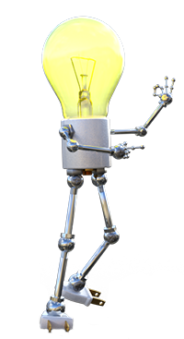

Software that focusses on running the computer rather than making you more productive.
System Software is all the software that is used:
to control hardware
manage and maintain your computer
enable communication with networks
manage databases
allow you to develop software
That's quite a load of tasks!
Obviously in this course you will be doing a lot of practical work learning to use one type of System Software (i.e. A programming language).
On the theoretical side we will focus on Operating Systems, Utilities and Device drivers.
Explore them in the dropdowns below…
Operating Systems
Types of OS
An Embedded OS
This needs to be small and power efficient to manage the device it is built into - e.g. a washing machine, microwave, GPS navigator. Often this is designed more as a single purpose control program rather than a general purpose OS.
A Network OS
This type of OS focusses on managing and controlling communication and access to resources. It has to track and manage databases of users and resources (e.g. files, folders, software, hardware) and match them up so that only users with the correct permission can use specific resources.
Usually runs on servers.
A Supercomputer OS
This has to be good at managing the splitting up of tasks and running them in parallel across thousands of CPUs and GPUs at the same time.
Runs on Supercomputers.
A Desktop OS
This needs to provide a good user interface, an API (Application Programming Interface) to allow programmers to create productivity software, good hardware and communications support, etc.
Runs on laptops and desktops and some types of tablets.
A Mobile OS
This needs to be very energy efficient (it is always on), provide support for touchscreen interfaces as well as voice control and sensors, and provide excellent communications control.
Runs on smartphones and tablets.
A Real Time OS
This OS has to manage hardware that has to respond in real time to commands (i.e. there can be no delays in its response).
Controls machinery - e.g. a rocket or missile.
OS and Standardisation

The vital importance of standardisation.
The focus of creating an operating system is to
make a computer behave in a standard, predictable way for both the user and the software / hardware developer.
The creator of the Operating System defines the way that programs should look, feel and operate - and the way that the OS controls the hardware.
This standardisation makes it easier for people to design and create computer hardware and peripherals (there are set, clearly specified ways for the hardware to communicate with and work with the OS).
Standardisation means that software designers don't have to spend so much time on User Interface design (they know what menus, buttons, etc. must look like to fit in with all the other software that runs on that OS). They also don't have to worry about controlling every different type of hardware out there because the OS will do that for them.
Finally, the user knows that the software will look the same and work the same and so be easier to use.
Of course, different people / groups have different ideas of what the standards should be - which is why the three major OS's (Windows, Linux, macOS) are different.

APIs
Programmers no longer write software for specific hardware - in fact the OS limits and restricts direct access to hardware. Programmers must instead write their software to use the OS's API (Application Programmers Interface). The API is a set of libraries and instructions provided by the OS that provides the standardised way to work with hardware.
Because each OS has its own, different set of APIs, software written for Windows will not work on macOS - even though the computer may have the same hardware!
Examples of OS's
Windows
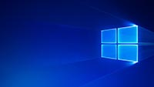
Windows is an Operating System designed and developed by Microsoft.
The latest version is Windows 10.
Windows is the most popular desktop / laptop OS in the world.
Windows is available in both 32 bit and 64 bit versions.
Attempts have been made to get Windows to work on smartphones and tablets. The smartphone version of Windows has been discontinued and so has the special tablet version.
Windows based smartphones are no longer being made or sold. Windows based tablets run the full version of the OS.
Windows has been designed and developed to run on processors from Intel or AMD.
Back to the top of this Panel
macOS
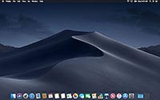
MacOS is designed and developed by Apple to run on Apple designed laptop and desktop computers (i.e. MacBooks, iMacs and the Mac Pro.
The latest version is macOS Mojave.
Before changing the name to macOS, Apple's OS was called OS X.
macOS has a reputation for being more stable and reliable than Windows. Part of the reason for this is that Apple controls both the hardware and the software of its computers and can make sure that they work really well together. The OS only has to work with a limited, controlled set of hardware.
Windows, on the other hand, is meant to run on any hardware configuration out there - and this creates much more potential for conflicting components and drivers.
macOS also has a reputation of having less problems with malware. Again, this is a function of scale. If you were a creator of malware would you rather write your software to run on 5% of the desktop / laptop computers out there (macOS) or for the far larger share of the market that Windows commands?
Apple's mobile OS (iOS) is based on macOs so there has been no attempt to make a full version of macOS run on a mobile device.
There are people that like the way macOS works but do not want to buy Apple computer hardware. They build their own computers with normal PC hardware and then figure out how to get macOS running on their computers. Such a computer is called a Hackintosh and there are
whole online communities and forums
dedicated to this topic.
macOS is a 64 bit OS.
macOS is based on Unix and written to run on processors from Intel.
Back to the top of this Panel
Linux
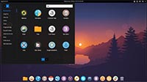
Linux is an OSS (free) OS based on Unix.
The kernel (the central core of the OS) was written by
Linus Torvalds
as part of his masters dissertation. Linus still retains control of the development of the Linux kernel today.
Other elements of the OS were created and developed by the OSS community.
Linux is available with a GUI as a desktop and laptop OS but its real popularity is as the software that runs most of the servers on the internet.
Linux scales well and is also the most popular OS for use on Supercomputers.
There are many versions of Linux available including
Red Hat
,
Debian
Mint
CentOS
and
Ubuntu
(developed by South African tech billionaire
Mark Shuttleworth
's Ubuntu Foundation).
Although you can download all versions of linux for free you will also find Linux being sold. If you buy such a Linux package you are paying for tech support, manual, installation packages, etc.
Linux is easily ported (i.e. It is easy to recompile Linux to run on computers with different CPUs and hardware configurations), which is why it is found on desktops, laptops, mobiles, servers and even Supercomputers.
Back to the top of this Panel
iOS and iPadOS
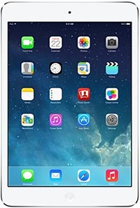
iOS is a mobile OS based on macOS designed and developed by Apple to run on Apple mobile devices (iPhone and iPad).
It is written for Apple designed ARM processors.
iOS is designed for a touchscreen interface and so will accept external keyboards (through Usb or Bluetooth connections) but will not work with a mouse.
iPads can accept accurate and precise drawing using Apple's Pencil accessory that lets the iPad work like a drawing tablet.
Back to the top of this Panel
Android
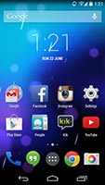
Android is a mobile OS developed by Google and given away for free to smartphone and tablet developers (as long as they include Google's mobile apps on their devices).
Android is based on Linux and is designed to run on ARM CPUs created by Qualcomm, Samsung and other manufacturers.
Android is the most popular OS in the world (based on sheer numbers, there are more Android devices made and sold than any other computing device).
Device manufacturers do, however, take the basic Android OS and add their own apps and features to the OS for each device that they deliver.
They are often slow to upgrade their customised software to work on newer versions of Android which means that many people who buy Android devices are unable to upgrade them to the latest version of the OS.
Back to the top of this Panel
Chrome
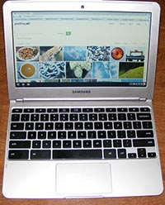
A chromebook looks just like a normal laptop runner a browser.
Chrome is an OS created by Google. It is based on Linux and used the Chrome Web Browser as its main user interface.
Chrome was designed to create cheap laptops with low hardware specifications that ran mainly web applications.
Newer chrome books (such as Google's own PixelBook) are expensive and good looking with decent hardware specifications - but still run mainly web applications.
Google is modifying the latest versions of Chrome to run Android and Linux applications as well, allowing Chrome users to use their computers even when they are not connected to the internet.
Back to the top of this Panel
Back to the top of the Dropdown List
What is the purpose / role of an OS?

Mange the hardware and software
A general description of the role of an OS is:
An OS is a group of related programs that manage the hardware and software of a computer system.
What does this mean exactly?
It means that the OS manages everything a computer does - the management tasks are explained in the panels below:
Provide a User Interface
CLI
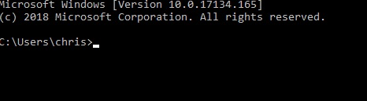
The command prompts for Windows 10 (above) and macOS (below).
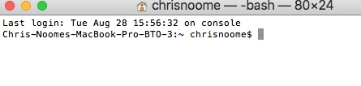

Command Line Interface
The User Interface is the way that the user interacts with the computing device.
In the first personal computers the user interface was a
CLI or Command Line Interface
.
When you switched on the computer you saw some text on the screen and a prompt that usually looked something likeC:\ >.
To get the computer to do anything you had to learn and know various text commands that you would type in.
The CLI is available even on computers that use a GUI as a standard interface.
To access the CLI in
Windows 10
, click the search icon in the task bar at the bottom of the screen and type in '
Command Prompt
' (without the quotes) and press enter. A window with the CLI will open up.
In
macOS
you simply start the
Terminal
app to get the command prompt.
The CLI is the default interface for Linux.
Various GUI interfaces can be loaded in Linux according to the user's preference - Unity, GNOME, KDE, Cinnamon are examples of some of the GUI environments available for Linux.
When Linux is being used on a server a GUI is pointless - no one is going to be using the computer as a desktop computer, so why slow the computer down with maintaining and managing a GUI environment? Instead SysOps access the computer remotely over the network and use the CLI to type in commands.
GUI
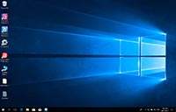
The Windows 10 GUI.

The GUI
The next development in the user interface was the
GUI (pronounced 'gooey') or Graphical User Interface
.
Here the user is presented with a graphically rich interface made up of windows, icons and menus that are accessed using a pointer - and the pointer is moved and controlled by a pointing device - usually a mouse.
This interface is easier to understand than having to remember a lot of text commands and type them in correctly.
The development of the GUI made computing a lot more friendly and easy to do.
Touch Interface
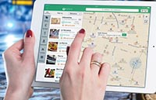

Touch Interfaces
After the GUI the next development in user interfaces was the
Touch Interface
- developed for mobile devices where keyboards and other pointing devices are not an option due to the small size of the devices.
Touch interfaces are even more intuitive and easy to use than a regular GUI and added the feature of gestures to the way that users could control their computing devices.

Did you know?
Touchscreens are so easy to use that researchers have used them to allow animals to communicate with us!
Voice / Sensor Interface
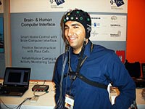
Image by Anders Sandberg from Flikr

Voice control / Sensor based interfaces
We are currently watching / living through the development of
sensor based user interfaces
- where the computer can be controlled by:
'listening' to and understanding your voice commands.
tracking the movement of various body parts and using those for input (e.g. Virtual Reality head tracking)
Sensors that monitor brain waves or muscle control impulses to allow for 'mind control' of computers or prosthetics.
other examples of the computer being aware of its environment and context through inputs from various sensors.
In this kind of interface the computer 'gets out of the way' - the interface feels even more natural and easy to use than a touchscreen is today.
Back to the top of this Panel
I/O Management
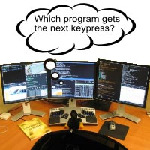
Image By Dons00 (English: self-made) [GFDL or CC-BY-SA-3.0], via Wikimedia Commons
You are working on your computer or computing device right now.
Quite possibly you have more than one program running - definitely a web browser to see the content on this site. Maybe your email software. Quite possibly a Word Processor for making notes. How about a music player for listening to music whilst you work?
Have you ever stopped to think about how these different programs know how to share the screen, keyboard, mouse, speaker, etc?
Tracking and managing this sharing of input and output devices is what is meant by I/O Management - and it is exclusively the job of the OS.
We are not going to go into technical detail about how this gets done. As you can imagine, it is quite a tricky task!
Back to the top of this Panel
Memory Management
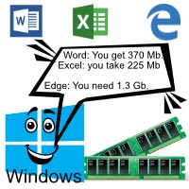
Every program that is running on your computer makes use of memory to store the data and instructions it is busy working with.
The thing is, no program knows which part of the memory is being used by any other program running on your computer.
As you can imagine, this could easily lead to disaster - if one program put its data into a section of memory being used by another program then that program would end up trying to work with the wrong data - and probably crash!
Luckily one of the major jobs the OS does is to keep track of which program is using which bit of memory.
In fact the OS is incredibly strict and will never allow any program to access memory (to read or write) that is marked as being used by another program.
This is what is meant by Memory Management.
Back to the top of this Panel
Storage Management
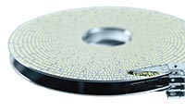
The basic unit of storage from the user's point of view is the file.
But that's not how the computer sees it.
From the computer's point of view data is stored in bits, bytes or clusters (larger groups of bytes) located somewhere on a spinning magnetic disk, spinning optical disk or in the memory chips of electronic storage.
These locations all have an address which can be used to read / write the data at that specific location.
Files are generally large enough that their contents are spread across more than one physical location across the storage medium.
The OS's job is to provide a human readable file structure (folders and files) and map that to a computer hardware structure - amounts of data stored in specific places on media.

Loading a file
When you 'load' a file the OS :
looks up the file name in its file structure.
It finds the recorded location of the first part of the file on storage
It reads the data from that location in storage and copies that data into memory.
It checks the end of that data to see if there is a link to another location on the storage medium.
If there is a link then it reads the data from that location, copies it into memory - and checks for a link…
It repeats the step above until the last data read does not have a link - this means the end of the file has been found - and all the data from the file has been read into memory.

Managing shared access
On top of all of this, the OS has got to make sure that no two programs are trying to write to the same file at once (because that would just result in corrupt data).
Sometimes the OS has to make sure that no programs can have the same file open at the same time.
Getting all this done is what is meant when talking about the Storage Management function of an OS.
Back to the top of this Panel
Process (CPU) Management
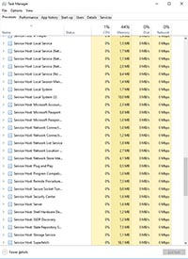
Today's computers and OS's aremultitasking.
This means that they do more than one thing at the same time.
In fact, even when your computer has just started up and you have not started to run any other programs it is already running many separate tasks (remember the OS is made up of many programs working together to manage your computer).
Some programs even split themselves into many parts (called processes) that run at the same time (this is multi-threading).
Tip:
You can see which programs are running in Windows by typing 'Task Manager' into the search box in the taskbar. When the app opens click 'More details' in the bottom left corner and you will see all the processes that are running (thats what the illustration on the left shows).
In macOS you press Command+Space to open the search tool and type in 'Activity Monitor' to start the app.
In Linux you press the 'Super' key (the 'Windows' key on the keyboard) and search for System Monitor.
If you look at the list of running programs you will see that it is longer than the number of cores / threads on your CPU!
How is this possible?
Well,
the OS divides the CPU's activity into time slots and then allocates time slots to all the programs / processes that are running. This way each program / process gets a bit of CPU time.
Remember that the CPU can handle billions of instructions per second - so these bits of time and processing happen so quickly that we users are never aware of the fact that each program is not running with the full attention of the cPU all the time!
It is the
OS's job to keep track of which tasks or processes are running - and to make sure that they each get a slice of CPU time
so that they can all seem to be running at the same time.
This is what is meant when we talk about Process (or CPU) Management.
Back to the top of this Panel
Back to the top of the Dropdown List
Utility Software

Add extra tools to your toolkit
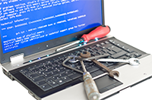
Utility software is created to make maintaining your computer easier.
The OS does most of the heavy lifting and provides lots of tools to manage you computer - for example Windows provides:
Defragment and Optimise drives
This tool helps group your files together so that your disk reads data faster and so the overall performance of your computer improves.
Computer Management
This tool lets you see and manage many aspects of your computer's hardware - from formatting storage to checking the drivers (drivers are explained in the next dropdown) and even scheduling tasks to run automatically at set times.
Windows Defender
This is a built in anti-malware tool and firewall.
And more.. (use the search tool and type in 'Administrative Tools' to open a folder of shortcuts to the built in utilities in Windows 10).
In macOS you press Command+Space and type in 'Utilities' then make sure you choose the Utilities folder from the list that you get shown. This will give you a list of macOS's built in utilities.

Third Party Utilities
These are programs written by people who recognise that the OS's built in utilities do not do everything, nor are they powerful enough. They realise that people will buy additional software that can help them manage their computer better.
Examples of such utility software include:
Anti-malware software
for more about this see the Social Implications Chapter.
Backup software
This type of utility lets you backup your software and data to external media (a hard drive, flash drive, SSD or magnetic tape) or even to the cloud (see the Data Communications chapter for more on the cloud).
Everyone should make backups because you never know when your computer can fail / crash or be stolen).
Syncing software
This kind of utility is usually included when you use cloud storage - you set it up so that your various devices can keep their files up to date with a set of files stored in the cloud. It means, for example, that if you edit a file on your desktop computer it will automatically be updated in the cloud and on your laptop / mobile device.
Tune Up utility
This software gets rid of duplicate files, frees up disk space, manages which programs load when your computer starts, and can even defragment your storage. Its general purpose is to clean up the junk that accumulates in your system (just like your room gets a bit messy over time) and keep your computer from slowing down.
Recovery tools
These are programs that can try to recover files that have been deleted from storage and memory cards - even if the memory cards, for example, have been formatted. They don't always guarantee success, but unless a file has been overwritten by other data these utilities can usually recover it.
There are many other sorts of utilities out there, but we aren't even going to try to describe them all!
You really do need to know that there are extra utilities available - and that they make managing your computer easier than just relying on the OS and its tools.
Back to the top of the Dropdown List
Device Drivers

Controlling the hardware
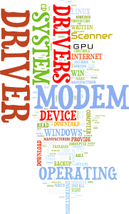
There are many, many different makes and models of each type of hardware - all made by different companies, all with their own circuitry designs and ways of making the hardware work.
Just think of keyboards, mouses and printers.
How many different types of these peripherals have you seen?
Can you imagine a OS developer having to try to write the software to control all these devices - especially seeing as each one can work in its own unique way?
It seems impossible - and it is!
What the OS developer does is say:
OK - so this is a Printer. Our OS sends output to a Printer in this way: (provide a list of output types). The OS will also send the following commands and data to a Printer: (provide a list of commands and data output and formats). And so on…
Then the OS developer expects the makers of printers to write
software to convert the data the OS sends out / accepts to something the printer understands and can work with.
This software will also convert the data / commands the printer sends to the OS to match what the OS is expecting.
The software that does this task is called aDriver.
Because drivers standardise how the OS expects to work with the hardware, programmers can write their productivity applications without wondering how to make it work with all the different types of hardware out there. All they have to do is make sure their software uses the OS specified commands to control, for example, a printer.
This is why whenever you add new hardware to your computer it needs to install a driver.
Some things to know about drivers:
The OS usually has a set of standard drivers that many devices are designed to work with - e.g. for keyboards and mouses. Only if the device has special features (e.g. a gaming mouse with extra buttons) does it really need a driver of its own.
Most drivers are installed by a process known as Plug 'n Play.
You connect the hardware for the first time.
The OS checks if the device can use a standard driver.
If not, the OS checks if the hardware's driver is installed.
If not it asks you to install the driver from the supplied optical disc / flash drive - or simply downloads the latest driver from the web.
The driver is then installed and most times your new hardware is ready to use.
Only sometimes (e.g. video cards) will you have to reboot before you can use your hardware.
If a particular hardware device is performing slowly or crashing / failing frequently then one of the first things to check is if there is a driver update available. Installing a driver update can often solve the problem.
Driver updates can be downloaded from the hardware manufacturer's web site. Be sure to get the correct driver for your hardware model and your OS.
Some devices - especially video cards - have their drivers updated relatively frequently. It is a good idea to check for and install the latest driver as it will usually improve device performance and stability.

How a driver works
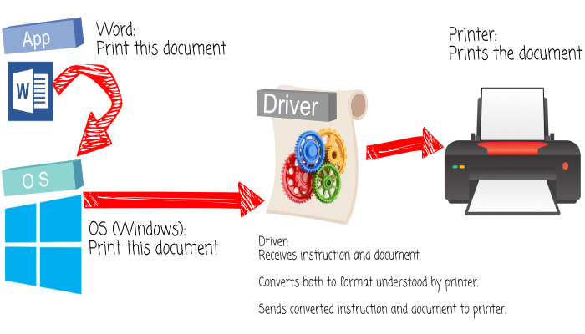
Back to the top of the Dropdown List

Video Links - System Software
We have selected and curated a set of videos on YouTube related to your course.
These videos are not created or owned by us.
They may display advertising and in some cases may contain limited amounts of swearing.

